Manchester Deaf Centre - Room Hire Request Form

Person Enquiring / Booking

Name of company / organisation / group

Email

Phone Number

Date(s) Requested

Time(s) Requested

Number of Attendees

Name of Event (if appropriate)

Type of Event (eg conference, meeting, fundraiser, training, etc)

Room(s) Requested – Please delete / highlight as appropriate | Teddy Webb Hall (Large)  Teddy Webb Hall (Small)  Teddy Webb Hall (Whole)  Kitchen  Lounge / Riley’s Bar  Meeting Room 2  Youth Space
Room Set Up / Layout – Please delete / highlight as appropriate | Blank Canvas  U Shape with tables  U Shape without tables  Boardroom  Theatre  Classroom  Other – please specify / discuss with MDC  *max capacity
Additional Requests (no extra cost!) – Please delete / highlight as appropriate | Wi-Fi  TV Screen / HDMI Cable for Laptops (USB-C adapter is available on request)  Flip chart, paper and pens
Specific Requests and Accessibility Information | Do any participants have mobility issues or require wheelchair accessibility?
Catering Requests | Tea and coffee complimentary for up to 30 attendees.  *For groups numbering over 30 participants, there will be supplementary charges. Please contact our bookings team for more information.  We recommend our friends over at Open Kitchen Manchester! or Cracking Good Food! You can order from them directly.
How is attendance at the event being arranged?  – Please delete / highlight as appropriate | Invite only | Open invite; however, attendees need to book onto the event |  | Open invite; open to any member of the public without pre-booking
How is the event being advertised? (eg, word of mouth, social media, flyers, website) |  | Will the media be present?  YES/NO
Name and contact details of main speaker (incl organisation / group / charity they represent)

Name and contact details of all other speakers (incl organisation / group / charity they represent)

Total Cost | For office use only
Further consideration  For office use only | YES/NO  For office use only |  | STAFF INITIALS  For office use only

YOUR FINANCE DEPARTMENT DETAILS
Please provide the below details in order for Manchester Deaf Centre to invoice you for the services provided:

Finance Department Contact Name
Finance Department Address
Finance Department Email
Finance Department Phone Number
Purchase Order Number Required Y/N

MDC – Room Hire Fees and Additional Information
Room | Half Day  1-4hrs | Full Day  4-9hrs | Weekend (Half day) | Weekend (Full day)
Teddy Webb Hall (Whole) | £265 | £400 | £330 | £500
Teddy Webb Hall (Large) | £210 | £315 | £265 | £400
Teddy Webb Hall (Small) | £160 | £240 | £200 | £300
Kitchen | Please enquire for further details
Lounge | £160 | £240 | £200 | £300
Meeting Room 2 | £190 | £265 | £240 | £330
Youth Space | £160 | £240 | £200 | £300
Riley's Bar | Please contact  aishaahmed@manchesterdeafcentre.com  for more information.

*Half day fee refers to any booking between 1-4 hours (e.g. 9am-1pm / 1pm-5pm)

*Full day fee refers to any booking between 4-9 hours (e.g. 9am-5pm)

*Evening requests after 5pm please contact aishaahmed@manchesterdeafcentre.com
*Discounts: if you are making a block booking of more than 6, or booking more than 1 room, you may be eligible for a discount. You can discuss this with our bookings team.
Also available to hire
Riley’s bar
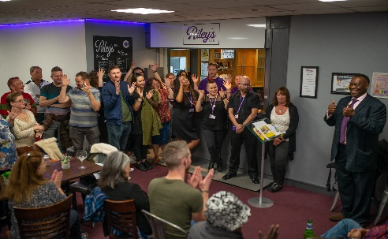
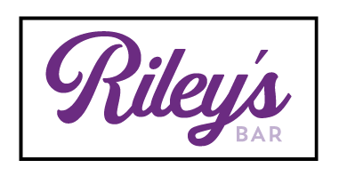
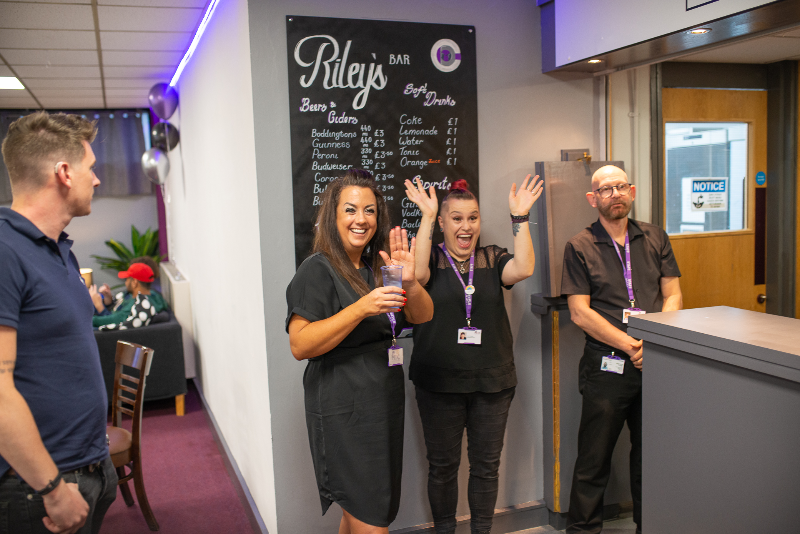

Riley’s Bar is a fully accessible and deaf friendly bar. It is situated in between the Teddy Webb Hall and the Lounge and we can serve drinks to events in either of these rooms. Please talk to our bookings team about opening Riley’s and the additional fees associated with this.

Cancellation Terms and Conditions

- 15 days’ notice or more before the booking date: no cancellation fee
- 8-14 days’ notice before the booking date: 50% cancellation fee
- 1-7 days’ notice before the booking date: full charge applies

Venue Hire Statement

We are delighted that you have chosen to hire our venue for your meeting or event. We hope that you and your guests will enjoy the facilities that we offer.
We have a responsibility to ensure that our venue is not used for any unlawful or inappropriate purposes. Therefore, we ask you to agree to the following terms and conditions:
- To not use the venue for any activity that promotes or incites violence, hatred, discrimination, or extremism of any kind, whether based on race, religion, gender, sexuality, or any other characteristic.
- To not invite or allow any speaker or performer who is known to have expressed or endorsed such views, or who is subject to any legal restrictions or sanctions in relation to their activities or affiliations.
- To not display or distribute any material that contains or advocates such views, or that is offensive, abusive, defamatory, or illegal.
- To comply with all applicable laws and regulations, and respect the rights and dignity of all people who use or work at the venue.
- If you have any concerns or issues of this nature in relation to your event, to report these to us.
- To cooperate with us and any relevant authorities if we have any concerns or queries about your event or its participants.
If any of these terms and conditions are breached, we reserve the right to cancel your booking, terminate your event, and/or report you to the appropriate authorities. We may also refuse to accept any future bookings from you.
We appreciate your understanding and cooperation in this matter. We want our venue to be a safe and welcoming place for everyone.

Thank you for choosing us for your event.

Facilities and Parking

Our Location
Manchester Deaf Centre is in a fantastic location, centrally located with easy access to popular bus routes. Only a 10-minute walk from Oxford Road train station and St. Peter’s Square Metrolink. For those travelling by car, the Aquatics Centre car-park is situated on Booth St East, just a 2-minute walk from MDC. The building is wheelchair accessible and has a lift which enables access to all areas of the building.

Our Rooms

We have various rooms available for hire at MDC with varying capacities. All rooms have access to screens (perfect for delivering presentations or information sharing), all rooms are wheelchair accessible, have air conditioning and can be set up in various styles per the client’s request. We can facilitate bookings from 12 participants up to 100 participants. Our rooms can facilitate meetings, workshops, interviews, training sessions, cooking lessons (as we have a fantastic kitchen available for hire as well), charity events, the list is endless! If you need a room, our helpful admin staff are always available to discuss your requirements and advise which room would be best suited to your needs.

Additional Services

Require a BSL interpreter, lip speaker or note-taker at your event? Contact our bookings team on 0161 273 6699 or email bookings@manchesterdeafcentre.com and we will happily assist.

